What Parameters Impact the Outcome of Viable Dissociated Cells
Posted by Luke Doiron on Jul 29, 2015 3:11:00 PM
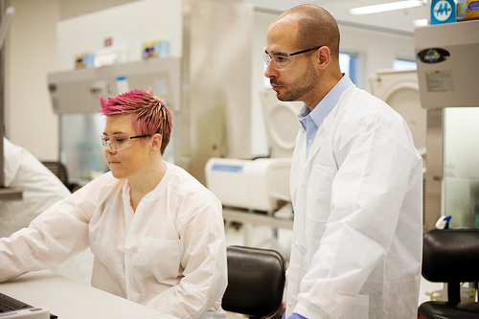
When cell isolation is the goal, selecting the right protocol can greatly influence cell viability and yield, and therefore impact your research data. This is why it's important to understand what parameters effect the outcome of cell dissociation processes, so you select the correct materials and methods for your desired endpoint anddownstream application.
There are eight primary factors that impact the outcome of cell dissociation. While factors concerning the first three listed below are generally not controllable, other dissociation parameters can be managed to achieve optimal results.

Tissue type
Tissues vary considerably in their structure and cellular composition and therefore respond differently to specific dissociation materials and techniques. For example, assume you're working with human uterine epithelial cells.Published research points to the need to use three different enzymes, in an HBSS medium. Now let's suppose we're working with human corneal epithelial cells. Published isolation protocol requires two enzymes and a DMEM/F12 dissociation medium.

Species of origin
Researchers work with a variety of species and these have varying requirements for cell isolation techniques. Maybe you're using rat mesenchymal stem cells; published dissociation parameters call for collagenase 1 in a DMEM medium. But if using human mesenchymal stem cells, this protocol calls for collagenase type 1 and deoxyribonuclease I enzymes in a DMEM/F12 medium.

Dissociation medium
Commonly-used dissociation mediums include Hank's balanced salt solution (HBSS), Roswell Park Memorial Institute medium (RPMI), Dulbecco's Modified Eagle's medium (DMEM) and phosphate-buffered saline (PBS). Your choice of medium depends on other parameters, including the type of cell you're isolating. For example, RPMI is often used for isolation and growth of human lymphoid cells.

Enzymes used
This is one of the most significant parameters in cell isolation protocols. As we discussed in another blog, your choice of enzyme is highly dependent on your research goal and your tissue type. Common enzyme choices include collagenase, trypsin, papain and hyaluronidase.

Impurities in crude enzyme preparations
Historically, variations in data obtained from tissue dissociation procedures often resulted from the use of crude and undefined enzyme preparations used in cell isolation. Happily, today there are a number of refined, commercially available enzyme products that improve the reproducibility of results.

Enzyme concentrations used
A sometimes frustrating experimental variable, researchers must find the right concentration of enzyme needed for their specific application. Use a too-high concentration and you may get low yields and low viability, because dissociation occurs too aggressively. On the other hand, if your yields are low but viability is high, then the enzyme concentration may need increasing.

Temperature
Typically, once tissue is minced or cut into smaller pieces, washed in the appropriate buffer, and the appropriate enzyme(s) added, the mixture is incubated at a specific temperature. The most common temperature used for cell dissociation is 37°C, but this can vary depending on tissue type and other parameters discussed here.

Incubation time(s)
Last but not least, obtaining high yields and good cell viability depends in part on how long tissue mixtures are incubated. Too long, and there may be excess enzyme proteolytic activity, damaging cell viability. Not long enough, and there will be inadequate digestion, causing low yields.

